THE SWISS COLONY CHEESE DAYS PARADE - GUIDELINES
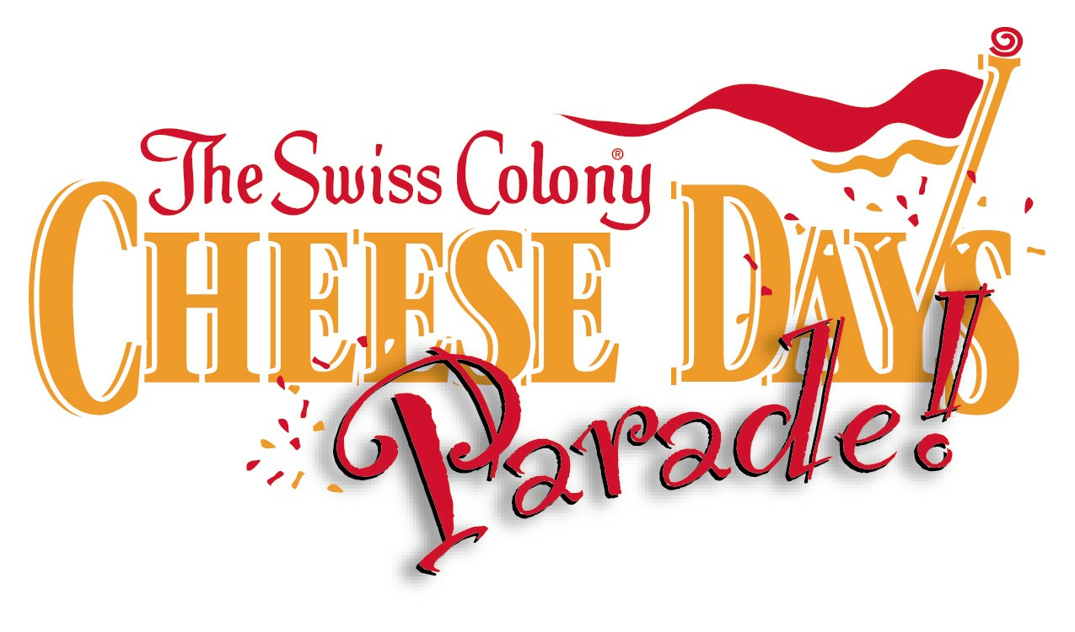

Sunday, September 18, 2016 – 12:30 pm

Questions? 608.325.7771 or email CheeseDaysParade2016@gmail.com

The mission of the festival and the parade is to honor the area’s Swiss heritage and cheese/dairy industries, as well as to provide entertainment. Entries deemed unsafe, overly commercial, or inappropriate will not be accepted.

Floats and units (businesses, groups, clubs) are eligible for prizes in the following categories:
Best Decorated
Best Theme
All entries are eligible for the People’s Choice Award (parade viewers will be invited to vote)
$100 TOP PRIZE FOR ALL 3 CATEGORIES

- No semi tractors or other large trucks are allowed to pull floats. The following tow vehicles ARE allowed: pickup trucks, utility vehicles, cars, horses, and small or medium sized tractors.

- Business, group and club entries are limited to those located in Green County. Exceptions MAY be made for affiliations with the cheese/dairy industry or Swiss heritage (at discretion of Cheese Days Board).

- THEME: Floats or units (yellow application) MUST be decorated and/or signed to reflect one of the following: cheese, dairy farming industry, or Swiss heritage. Entries not following theme information they have specified on application will be removed from the parade line-up at the discretion of the parade committee.

- NOTHING MAY BE THROWN. NO HANDING OUT OF LITERATURE OR PAPER. Individuals accompanying units on foot may hand out treats/gifts (candy, pencils, etc). Any unit found throwing items or distributing paper literature will be removed from the parade. Indicate on your application the items you intend to distribute. Please use appropriate buckets, baskets or other nice looking containers to hand out treats.

- Due to safety concerns - ONLY ONE DRIVER PER TRACTOR (no riders!) – this will be strictly enforced.

- No antique cars unless they are being used to transport dignitaries on behalf of the parade.

- No advertising is allowed other than a sign displaying the sponsor’s name or business logo. All other advertising on unit or tow vehicle must be covered unless the advertising on the vehicle is also the sole sponsor of the unit.

- All vehicles pulling floats must be clean, presentable, and ideally - decorated.

- If your unit includes people walking, they must be able to keep up with the pace of the parade! The route is 2 miles long. If you are handing out items and start to fall behind, we ask that you please stop handing out and catch up. Parade officials will be monitoring the flow at intersections – please follow their directions. For the enjoyment of the viewers, please try to stay within a reasonably close distance to the unit ahead of yours.

- Consumption of alcoholic beverages and smoking are not allowed around parade entries and on parade route.

- No political office holders, political parties, or candidates allowed in parade.

- If Cheese Days is providing a convertible for a dignitary they will also provide the driver.

ADDITIONAL INFORMATION FOR MUSICAL and ENTERTAINMENT GROUPS
  - Keep members together in their line-up area so the parade will not be delayed.
  - Inform school group members and parents of the location where musicians will disband following the parade (Northside Elementary School – near Fairgrounds).
  - Do not allow members to play instruments except for tuning and organized playing by the entire band.
  - Use of support vehicle in parade is NOT ALLOWED unless you have received PRIOR approval by parade chairpersons!

